Math
Houghton Mifflin Harcourt
Received 2015

Teacher Resources
Barcode ____________________  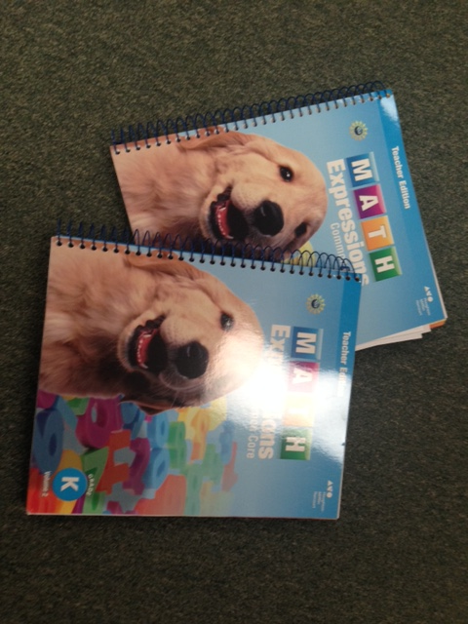 | Teacher Edition Collection (2 barcoded items)  - Volume 1 (1 of 2)  - Volume 2 (2 of 2) | $203.95
Barcode ____________________  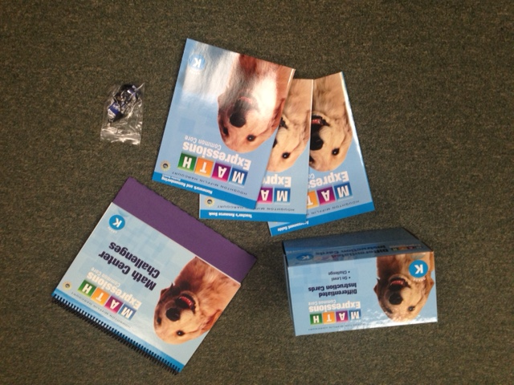 | Teacher Resources Kit (6 items-5 barcoded items)  - Flash drive  - Teacher Assessment Guide (1 of 5)  - Teacher Resource Book (2 of 5)  - Homework & Remembering Black Line Masters (3 of 5)  - Differentiated Instruction Cards Kit (4 of 5)  - Math Center Challenge Easel (5 of 5) | $623.25
Barcode ____________________  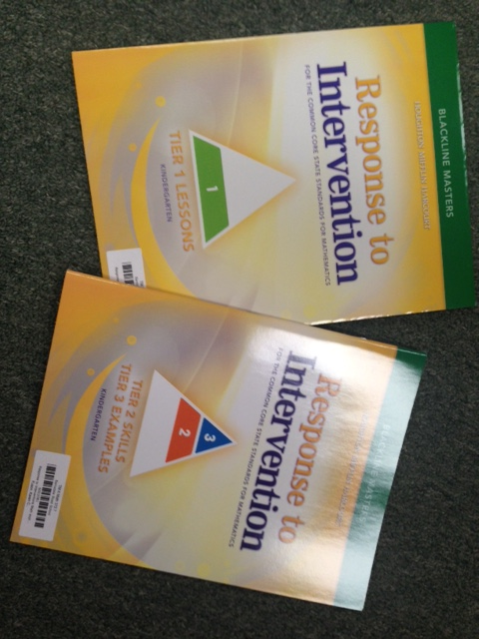 | Response to Intervention (2 barcoded items)  - Response to Intervention Tier 1 Black Line Masters (1 of 2)  - Response to Interventions Tier 2-3 Black Line Masters (2of 2) | $421.90

Manipulatives and Materials Kit
Barcode ____________________  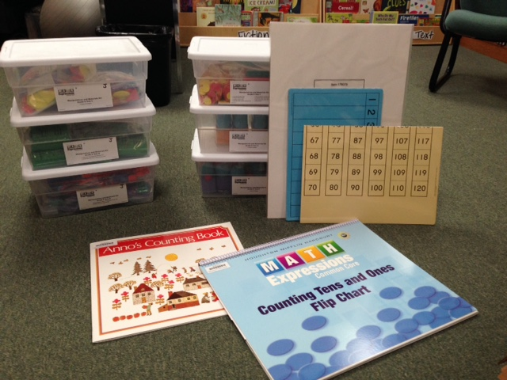 | Manipulative and Materials Kit  (2 barcoded items)  Anno’s Counting Book (1 of 2)  1-20 Number chart (set of 30)-blue  120 Math poster-ivory/yellow  Class Demo Board (sticky board)  Counting Tens and Ones Flip Chart (2 of 2)  Tote A:  - 7 sets Base Ten Rods (50 rods per set  - 15 sets Base Ten Units (100 units per set  Tote B:  - 30 Sets Inch and 5-Square Tiles  - 30 Sets Number Tiles and Symbols (14 per set)  Tote C:  - 10 Set 2-D Shapes  Tote D:  - 5 Sets 3-D Shapes  Tote E:  - 5 Sets 3-D Shapes  Tote F:  - 1 Set Giant Number Cards  - 1 Number Pattern Poster  - 1 Number Parade Poster  - 2 Sets Two-Colored Counters, red/yellow (200 per set)  - 1 Set Transparent Counters, Blue (36 per set) + labels  - 5 Sets Connecting Cubes (100 per set)  - 1 hand pointer | $1,039.20

Supporting Literature (each book is barcoded separately)
Barcode ____________________ | Anno’s Counting Book | $77.20
Barcode ____________________ | Three Little Pig by Galdone
Barcode ____________________ | Swan Harbor
Barcode ____________________ | One Less Fish
Barcode ____________________ | Rumble Bus
Barcode ____________________ | How Many Birds
Barcode ____________________ | What Comes From 2s, 3s,  and 4s?

